**WEB 215**

**M3T1 – Bootstrap**

**Assignment Notes**

Before you start, you should build an empty Bootstrap project as indicated in the Lecture Notes and videos. (I suggest copying your usual project template folder and then adding Bootstrap to it.)

If you do get stuck you are free to discuss the tutorial with other students.

Keep in mind that the next tutorial will continue to build on this one.

**Assignment Steps**

Here are the resources provided:

1. Wireframe.
   * In the real world, a [wireframe](http://en.wikipedia.org/wiki/Website_wireframe) is generated to represent the design the business owner desires. Being able to translate a wireframe into a final product is a key skill all web developers need to have. Remember, a wireframe **does not**need to be matched exactly; a wireframe is intended to be a rough sketch of the desired result.
2. Screenshot
   * If you're just getting started, or if the wireframe isn't clear about the target design, you can look at the screenshot. This is a sample of what the final result should look like.
3. Additional guidance
   * The additional guidance is provided to add clarity and help add context if needed.

**Assignment Scenario**

You have been tasked with creating a page to display the details of a record album. You will build this page up over the course of the next several labs. The starting page only needs to target medium and large devices; support for smaller devices will be added later.

These are the necessary components:

* A banner to display the name of the music store, Music Store
* Album information
  + An image on the left side to represent the cover art. The image is provided in the Blackboard post for this assignment.
  + The basic information on the album on the right side.

Finally, you have been requested to implement a new theme that is different from the default.

You are free to choose whatever theme you like, and are free to determine the sizing that you believe will work best for the page.

Wireframe

Use the wireframe to lay out your page.

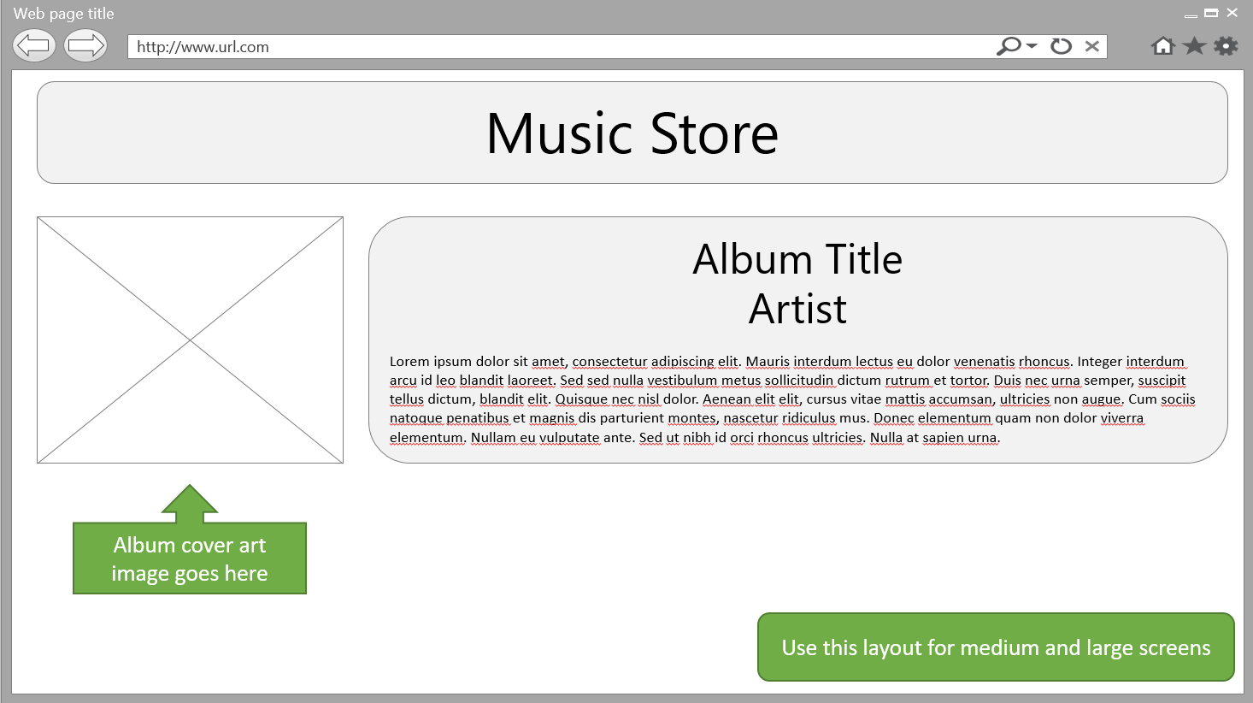

## Screenshot

This is what the solution should look like. The coloring will be different based on the theme you select.

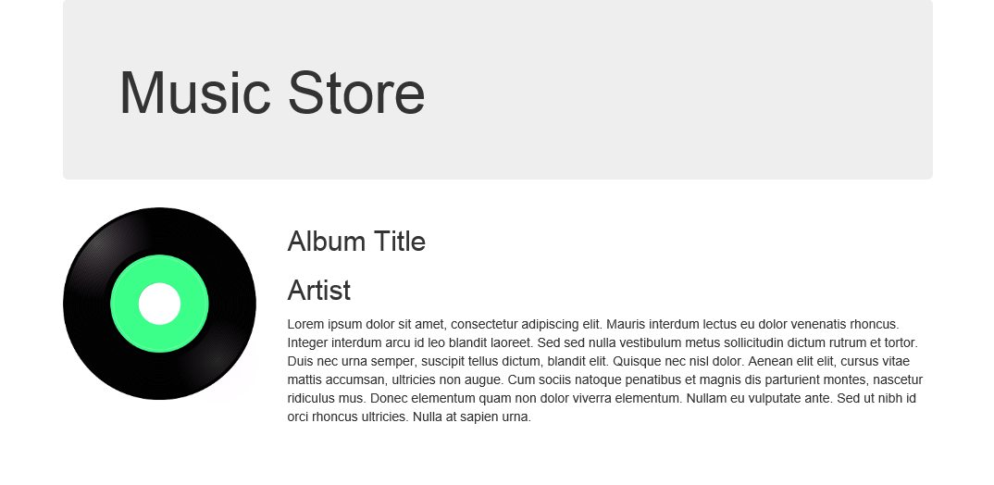

**Additional Guidance**

**Basic steps**

1. Download Bootstrap components from [www.getbootstrap.com](http://www.getbootstrap.com/).
2. Download the album art from the Blackboard post
3. Create a new project using your project template
4. Add a folder named "Styles". Add the Bootstrap css files to this folder.
5. Add a folder named "Scripts". Add the JavaScript files to this folder.
6. Add a new HTML page named AlbumDetails.html.
7. Add references to the Bootstrap min CSS file to AlbumDetails.html.
8. Add the necessary HTML to implement the layout. Use the phrases Music Store, Album Title, and Artist as placeholders as shown in the wireframe.
9. Obtain a new theme from [bootswatch.com](http://bootswatch.com/). Implement the new theme.

**Submitting M3T1**

Submit your zipped project folder in Blackboard.

Upload your project folder (unzipped) to your GitHub repository.